Lithium Recovery from Low Grade Resources
Prepared by:
Carly Merling
Faculty Advisors:
Dr. William Cross
Dr. Jon Kellar
Dr. Michael West
Director, SDSMT Advanced Material Processing Center
Dr. Alfred Boysen
Professor, Department of Humanities
Program Information:
National Science Foundation
Grant # DMR-1157074
Research Experience for Undergraduates
Summer 2012
South Dakota School of Mines and Technology
501 E Saint Joseph Street
Rapid City, SD 57701

Table of Contents
Abstract..........................................................................................................................................................................1
1. Introduction ..............................................................................................................................................................2
2. Broader Impact.........................................................................................................................................................3
3. Procedure...................................................................................................................................................................4
3.1 Materials....................................................................................................................................................4
3.2 Equipment.................................................................................................................................................6
3.3 Experimental Procedure..........................................................................................................................9
3.3.1 Polishing and Contact Angle.......………………………………………………………..….9
3.3.2 Preparation of Spodumene………………………………………………………………...10
3.3.3 Flotation…………………………………………………………………………………….11
4. Results......................................................................................................................................................................13
4.1 X-Ray Diffraction...................................................................................................................................13
4.2 Flotation and Contact Angle…..............................................................................................................14
5. Discussion….............................................................................................................................................................17
6. Conclusion................................................................................................................................................................19
7. Future Work………………………………………………………………………………………………………20
8. References ...............................................................................................................................................................21
9. Acknowledgments………………………………………………………………………………………………22

Abstract
The purpose of this project is to develop an effective separation technique which can ultimately process low grade lithium ores into a higher grade lithium product. Spodumene, lithium aluminum silicate, was collected from some mines located near Keystone, South Dakota. One sample was used to find the contact angle of spodumene while the rest was crushed and filtered to obtain a -48+100mesh fraction material size particles. X-ray diffraction demonstrated that the samples were essentially pure spodumene. The crushed spodumene was separated into 1 gram sized portions and then floated using different concentrations of sodium oleate. From concentrations of 0.001-0.004 M there is a good correlation between the percent recovery of spodumene and the contact angle of spodumene. However, at the extreme ends of the concentrations used for flotation, the recovery significantly declined, while the contact angle remained relatively high. The extreme low and high concentration contact angles were unexpected and could be due to surface roughness and or precipitation of metal oleate species at the mineral surface.

- Introduction
Lithium has the potential to be very important in the future industry, especially in rechargeable batteries. (National Research Council of the National Academies, 2008) It is also used as an addition to glass and ceramic bodies. The presence of lithium lowers melting points of certain processes or increases the cooling rate in others, and reduces the coefficient of thermal expansion and viscosity of certain materials. Thus lithium is very helpful in reducing toxic chemicals and contributing to energy savings for production and manufacturing. Lithium can be found in spodumene, which is lithium aluminum silicate, LiAl(Si₂O₆), and contains around 8% Li₂O (very rich for a natural source). (Sousa, 2007)
Manganese is a very important metal in industry and is rapidly growing in demand while its supply growth is not enough to satisfy the demand. This has caused the price of manganese to increase over the years, in particular from $1.3 in April 2010 to $1.55/lb in June 2011, which is a 19% increase in 14 months. (Xignite, 2008) In more recent years, the need for manganese arose mainly from the production and consumption in the steel and aluminum industries, especially in China. Because of this increasing demand, alternative processes must be found to identify and produce high grade manganese economically. (Zhang, 2007) There are also no companies in North America that recover manganese, so the United States steelmakers are solely dependent on foreign sources for their manganese requirements. (National Research Council of the National Academies, 2008)
One type of separation process that can be used to obtain a higher recovery of lithium from natural resources is froth flotation. Froth flotation is a process for separating minerals from gangue (unwanted material) by controlling their hydrophobicity. Through the use of surfactants and wetting agents, the hydrophobicity differences between the desired minerals and the waste gangue are increased. It is possible for complex ores to be economically and selectively separated through this process. (Fuerstenau, 1985)

- Broader Impact
In order to reduce the United States’ dependency on foreign resources and increase local production, effective methods of local recovery of manganese and lithium can be developed. This will also help lower the prices of the materials produced with lithium or manganese because local production will not have an imported materials tax and the shipping costs for manganese and lithium will be greatly reduced.

- Procedure
3.1 Materials
Manganese-bearing nodules are known to exist in the Chamberlain, South Dakota area. During a trip to that area samples were obtained and returned to South Dakota School of Mines and Technology for experimentation. (Figure 1)
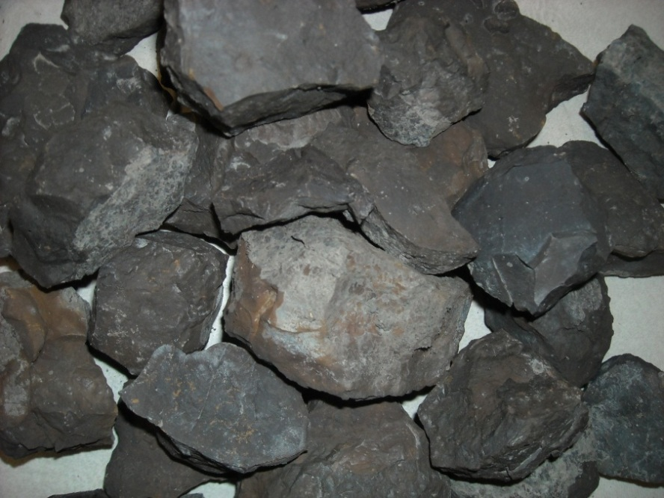
Figure 1: Manganese-bearing sea nodule samples
Lithium-bearing spodumene can be found in several mines in Keystone, South Dakota. Spodumene samples were taken from some of these mines for analysis and experimentation. (Figure 2)
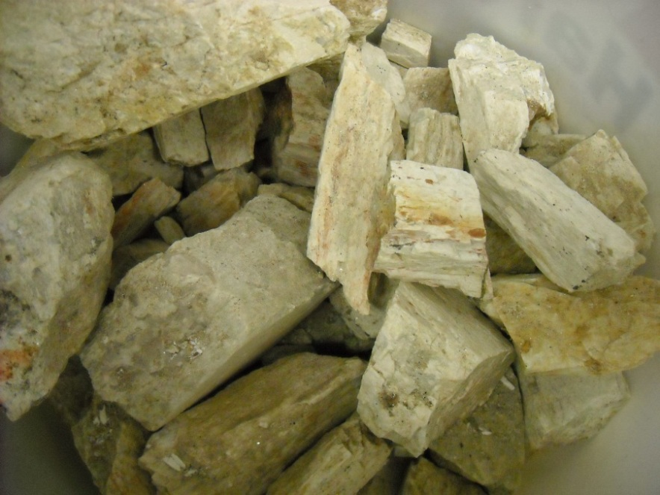
Figure 2: Lithium-bearing Spodumene samples

3.2 Equipment
The following equipment was used for the flotation experimentation:
- Figure 3: Hallimond tube flotation cell
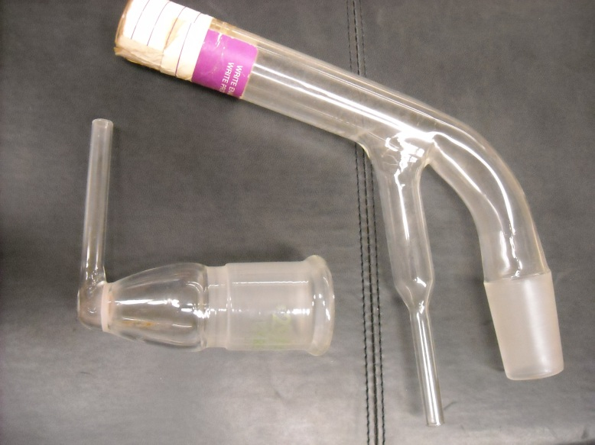
- Figure 4: Nitrogen flow meter
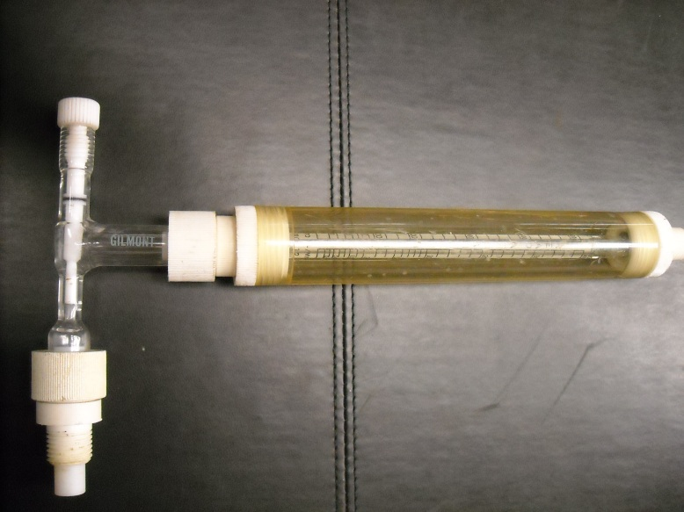

- Figure 5: Tygon tubes for nitrogen flow
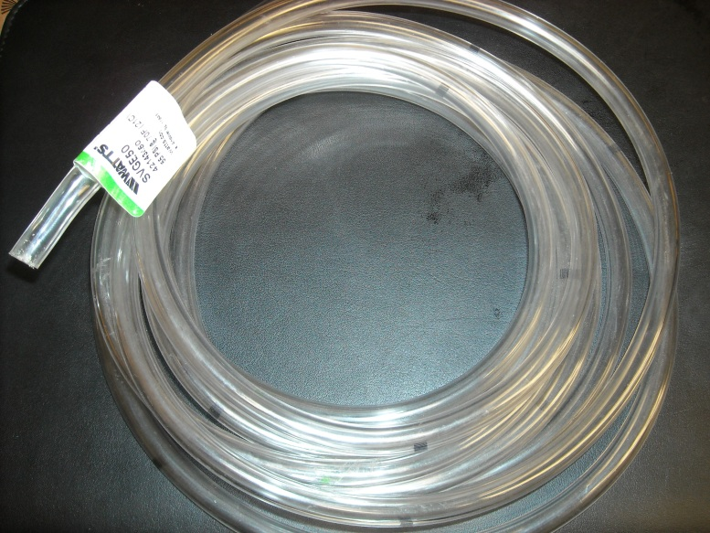
- Figure 6: Sodium oleate ≥99%, C₁₈H₃₃NaO₂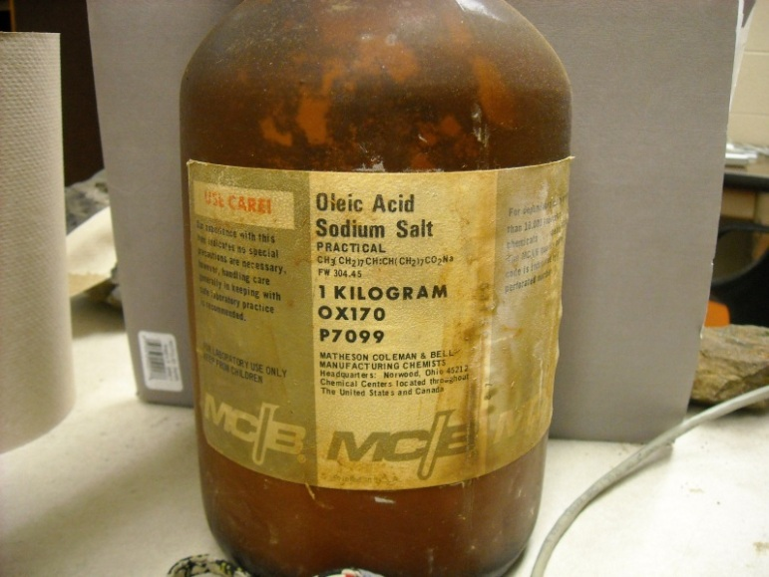

- Sodium hydroxide, NaOH, and hydrochloric acid, HCl

- Figure 7: Ramé-Hart Model 500 Advanced Goniometer Tensiometer with DROP image software
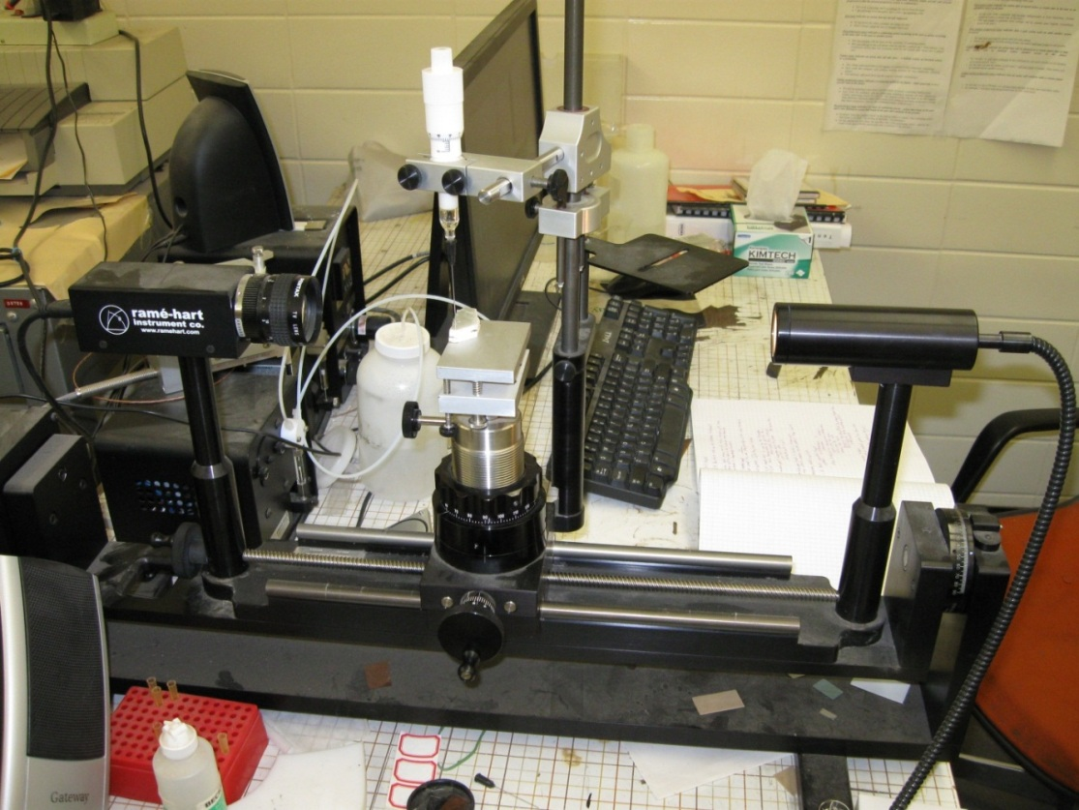
- Figure 8: Ohaus Moisture Determination Balance with Oven
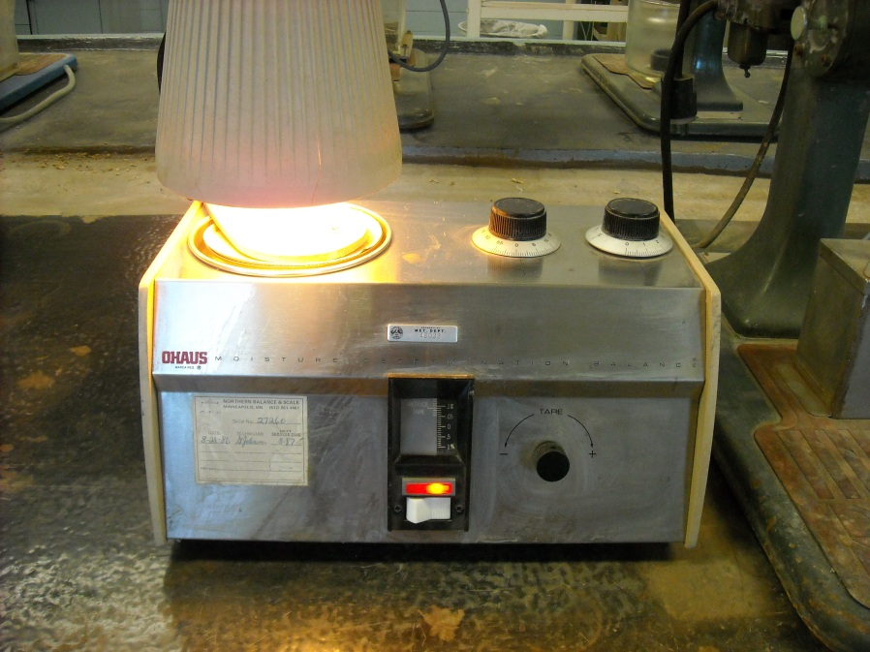
- X-ray diffraction instrument, Rigaka Model
  - Experimental Procedure
    - Polishing and Contact Angle
Nodule samples appearing to contain higher amounts of manganese were selected and polished to have two flat, parallel sides using grinder-polisher machines up to 0.3 microns. This was also done for the spodumene sample. Both samples were rinsed with tap water, brushed with nylon brushes, and left to dry (Figure 9).
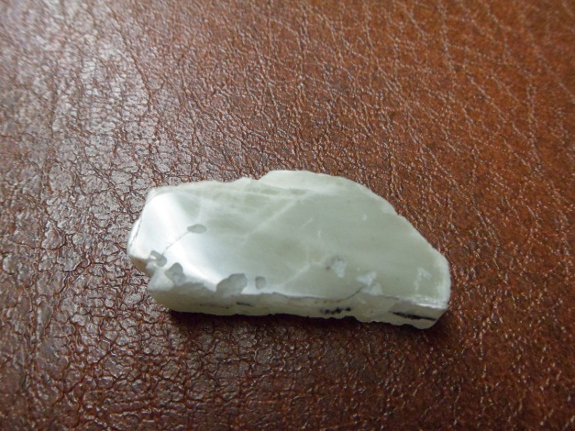
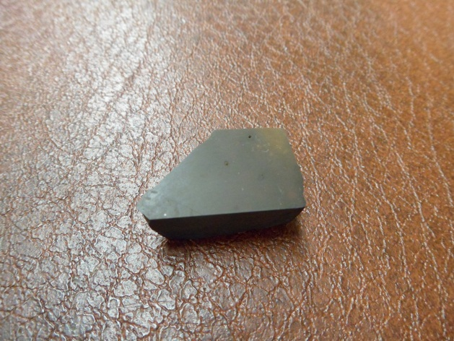
Figure 9: Polished manganese nodule and spodumene samples
The contact angles of these samples were measured using a contact angle goniometer (Figure 7). With this instrumentation, a 10µL drop of deionized water at pH 9 was carefully placed on the flat surface of the sample, such that it could be seen by the camera on the screen. The drop image program was used to determine the angles of the right and left sides of the droplet in the image once a second for ten seconds. The mean of these angles was calculated and recorded as well as the height and width of the droplet over this period of time. This was done several times for deionized water and different concentrations of sodium oleate in order to understand the variability in the contact angle measurements and see how these measurements change with respect to concentration.

    - Preparation of Spodumene
Some of the spodumene samples were crushed and ground by hand using a mortar and pestle (Figure 4). This was done in a fume hood with lung, eye and ear protection. The crushed sample was sieved using a -48+100 sieve nest and shaken by hand to separate the different sized particles. The sample pieces that were too large to fall through the 48 mesh sieve were ground again with the mortar and pestle until they were small enough to filter through. This process was repeated until about 100 grams of spodumene particles between 388 and 177 microns were obtained (Figure 4). Mineral particles of this size were recommended for Hallimond tube flotation (Feasby, 1966)
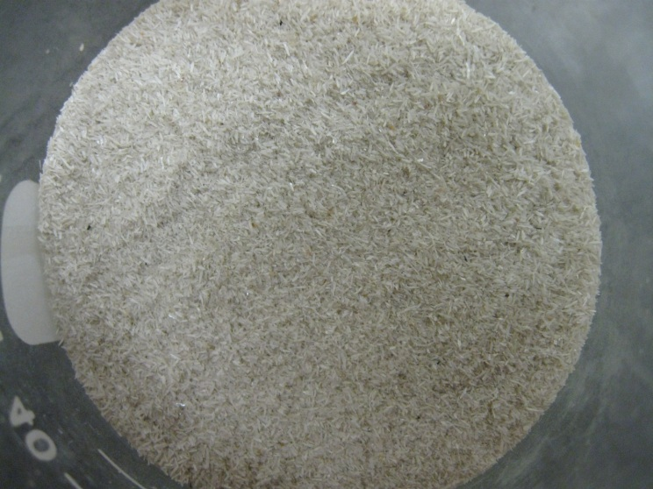
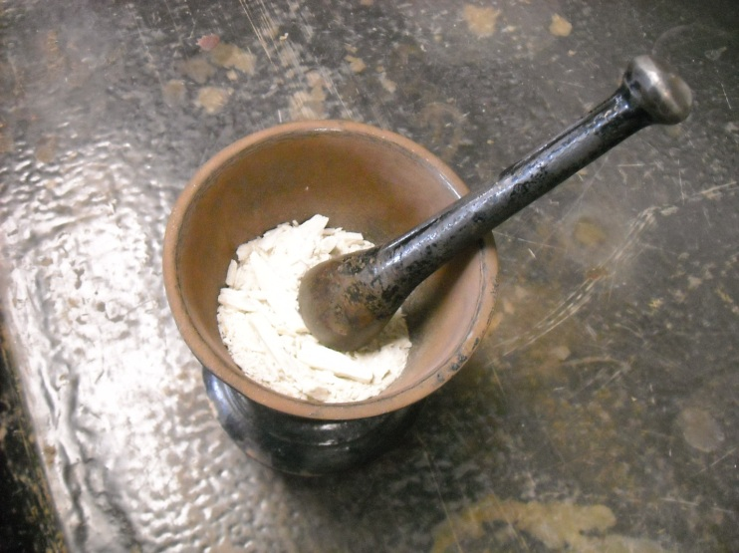
Figure 4: Grinding of spodumene (left), final spodumene particles after sieving (right)

    - Flotation
The Hallimond tube flotation cell was set up above a stir plate and connected to a nitrogen tank (Figure 5). One gram of the ground up spodumene was placed into the cell along with a magnetic stir bar and a sodium oleate solution at a specific concentration with a pH of 9. The different concentrations used were 0 M, 0.0001 M, 0.00015 M, 0.001 M, 0.002 M, 0.003 M, 0.004 M, and 0.005 M sodium oleate. The cell was prepped for about two minutes before beginning flotation. The stir plate was turned to 700 rps while the nitrogen flowed through the system at approximately 0.75 cc/sec for 8 minutes. Any froth that overflowed from the cell was collected in a beaker and combined with other floated material. The tailings and floating were collected separately and placed on watch glasses. To speed up the drying process, these watch glasses were heated under an Ohaus Oven for at least ten minutes, depending on the wetness of the sample. The concentrate and tailings from each trial were weighed separately and the recovery was calculated using the total sample collected.
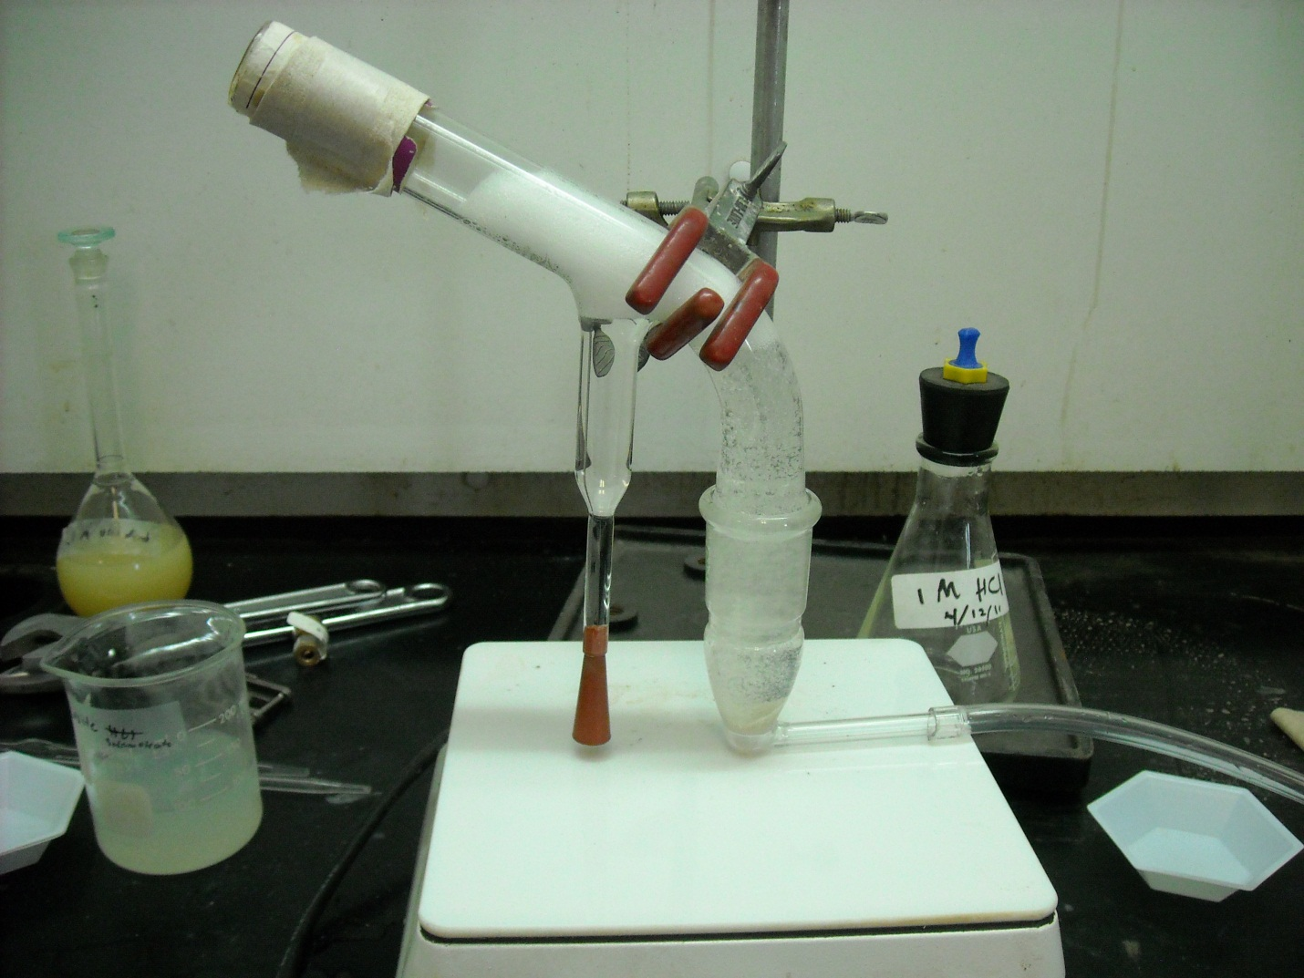
Nitrogen inlet
Initial sample location, tailings collection
Potential overflow of foam
Concentrate stem
Figure 5: Hallimond tube flotation cell with flotation in progress

- Results
Several kilograms of spodumene were collected from some of the mines near Keystone, South Dakota and several kilograms manganese-bearing nodules were collected from alongside the highway near Oacoma along the Missouri River.
4.1 X-Ray Diffraction
X-ray diffraction (XRD) was used to analyze the spodumene samples in order to determine if the samples were essentially all spodumene or if there were other impurities in the mineral. The XRD spectrum was compared to a reference spodumene spectrum from the Black Hills (Figure 6). XRD demonstrated a strong correlation between the spodumene samples collected and reference spodumene spectrum. This indicated the sample is essentially pure spodumene.

Figure 6: Experimental spodumene sample (blue) compared to a reference spodumene spectrum (red)
4.2 Flotation and Contact Angle
Table 1 contains the data collected and calculated from the flotation trials. The contact angle was not taken for the first two trials because the pH was recorded to be 8 while the desired pH for flotation was 9. Thus the first two trials were discarded. Figure 7 compares percent recovery and contact angle with regards to surfactant concentration from trials 3 to 13.

Sample Trial Number | Concentration of Sodium Oleate (mol/L) | Contact Angle  (°) | pH | Notes | Recovery (%) | Percent Spodumene lost in processing
1 | 0.001 M | - | 8 | Did not collect foam overflow | 43.1% | 17.99%
2 | 0.001 M | - | 8 | Collected foam overflow | 38.4% | 7.99%
3 | 0.001 M | 49.9 | 9 | Collected foam overflow | 37.5% | 7.15%
4 | 0.0015 M | 46.4 | 9 | Collected foam overflow | 42.0% | 4.12%
5 | 0.0050 M | 41.6 | 9 | Collected foam overflow | 15.3% | 3.05%
6 | 0.0001 M | 47.6 | 9 | Collected foam overflow | 0.312% | 0.94%
7 | 0.0005 M | 64.9 | 9 | Collected foam overflow | 15.85 | 3.33%
8 | 0.0000 M | 58.4 | 9 | Collected foam overflow | 0.071% | 0.74%
9 | 0.0030 M | 40.1 | 9 | Collected foam overflow | 32.6% | 1.73%
10 | 0.0040 M | 42.4 | 9 | Collected foam overflow | 34.4% | 2.98%
11 | 0.0020 M | 51.0 | 9 | Collected foam overflow | 37.6% | 1.33%
12 | 0.0010 M | 49.9 | 9 | Collected foam overflow | 49.0% | 2.70%
13 | 0.0010 M | 49.9 | 9 | Collected foam overflow | 39.1% | 1.61%
Table 1: Results of Hallimond tube flotation trials

Figure 7: Flotation of spodumene samples and contact angles with different concentrations of sodium oleate solutions at pH 9

The standard deviation of the recovery was calculated from the three flotation trials that were run at 0.001M sodium oleate. This deviation was 6.2 percent recovery with a 95% confidence interval of 7.0 percent recovery. When this deviation is added to the graph, it shows that the percent recovery of spodumene from the trials between 0.001 and 0.004 M sodium oleate are statistically equivalent. Thus the significance of their differences is questionable (see figure 8).

Figure 8: Flotation of spodumene samples and contact angles with different concentrations of sodium oleate solutions at pH 9 including the standard deviation of percent recovery.
- Discussion
Due to time constraints and the desire to conduct new research, spodumene became the focus of this project. Thus, the contact angle and the flotation separation process were not conducted on the manganese samples.
Obtaining consistent results with the contact angle goniometer was very difficult. The drop size was altered several times until a good volume was found that was not too large for the camera to record the entire drop but not too small as to not have a difference in advancing and receding angles. Even with a consistent volume of 10µL per drop, placing the liquid in one location on the sample without accidentally spreading the drop with the dropper rarely happened. Thus a lot of data was thrown out due to morphed droplets. Another inconsistency was the sample surface itself. The surface was polished but some smaller craters and cracks still existed on the surface which morphed the droplet. After the droplet was successfully placed, it naturally began to spread out and evaporate which then lowered the contact angle. To avoid this issue, the contact angle was measured as quickly as possible once the droplet was placed. This may explain why, at extreme high and extreme low concentrations of sodium oleate, the contact angles were unexpectedly high. The contact angle could have been measured prematurely before a more realistic equilibrium with the droplet on the surface could be reached. Because of all these factors, the contact angles obtained may not be as accurate as desired.
When the contact angles were first calculated, the angles were so variable that the surface was deemed to have too much inconsistency. After taking a closer look at the surface under a microscope, it was discovered that the polishing component was not completely removed from the surface and so was distributed all over the spodumene. After further cleaning with nylon brushes, the surface no longer had visible polishing component and the contact angles were more consistent.
Figure 6: Polished spodumene sample before cleaning with a nylon brush (left) and after (right)
When collecting the separated spodumene after performing flotation, the tailings were easier to collect than the floatings. The tailings remained in one location on the bottom of the Halllimond tube cell, so was easily scooped onto the watch glass for measurement. The concentrate, however, were not only in the concentrate stem, but also in an overflow beaker and stuck along all the inside of the flotation glassware. Thus, the recovery is likely to be lower than the actual amount of spodumene that floated due to loss from the collecting process.
As more trials were performed, the percent of spodumene lost from the initial amount used decreased, most likely due to the increased skills of the experimenter. Because of this, the standard deviation may not be as accurate as it could be because the data gathered to calculate the standard deviation came from one of the first trials and two of the last trials.

- Conclusion
X-ray diffraction demonstrated that the samples were essentially pure spodumene. Because of this, then the percent recovery is sufficient to analyze how successful each flotation trial floats spodumene rather than analyze specifically what floated and what remained in the tailings.
From concentrations of 0.001 to 0.004 M there is a consistent correlation between the percent recovery of spodumene and the contact angle of spodumene. With a higher contact angle, the percent recovery tended to increase as well. More data is necessary to conclude the significance of the concentration of surfactant with the contact angle differences and percent recovery.
However, at the extreme ends of the concentrations of flotation (from 0 M to 0.001 M sodium oleate and 0.005 M sodium oleate), the recovery significantly declined, while the contact angle remained relatively high. The extreme low and high concentration contact angles were unexpected because in general high contact angles mean the sample has high hydrophobicity, and thus, would be more likely to attach onto the nitrogen bubbles in flotation. These results could be due to surface roughness or precipitation of metal oleate species at the mineral surface. There is also a high chance that the contact angles were measured prematurely before the droplets fully expanded to their proper contact angles.
- Future Work
For future work, several variables regarding the Hallimond tube flotation can be changed. This project only had ten useful flotation trials, but more trials of different concentrations will help determine the significance of the changes in percent recovery and contact angle in relation to sodium oleate concentration. The pH of the system can be adjusted to a pH higher or lower than 9 in order to see how significant the pH affects the flotation recovery and contact angle. The time chosen to run a flotation can be increased to determine the most effective time in terms of percentage of floatings recovered. Finally, the particle size of the spodumene can be altered to determine the optimal particles size that is best for flotation.
More data on the contact angle of spodumene at different concentrations of sodium oleate is necessary to get a more accurate idea of the true contact angle. The contact angle can also be measured with a focus on how it changes as a function of time in order to reduce prematurely measuring the contact angle before the droplet fully spreads on the sample surface.
Finally, large scale froth flotation can be run on the samples to go beyond Hallimond tube flotation. This would be more applicable for industry to try large scale flotation and find out if the recovery is better or worse than small scale Hallimond tube flotation.

References
1. Amarante, M. M. (1999). Processing a Spodumene Ore to Obtain Lithium Concentrates for Addition to Glass and Ceramic Bodies. Minerals Engineering, 12(4), 433-436.

2. Brandt, F., & Haus, R. (2010). New Concepts for Lithium Minerals Processing. Minerals Engineering, 23(8), 659-661. doi:10.1016/j.mineng.2010.03.021

3. Botelho de Sousa, A. (2007). Beneficiation Studies on a Spodumene ore from Portugal. Developments in Mineral Processing, 13(2000), C11-40-C11-46.

4. Dennis, B. (1944). Manganese Extraction from Chamberlain Ore. (pp. 1-12). Rapid City, SD: South Dakota School of Mines and Technology.

5. Feasby, D. G. (1996). Investigation of Hallimond-Tube Flotation of Low Grade Phosphate Material. Minerals Research Laboratory, Lab. No. 1869 (Book 212).

6. Fisher, J. W. (2012). New developments in the recovery of manganese from lower-grade resources. Society for Mining, Metallurgy, and Exploration, Inc.,29(1), 61-74.

7. Fuerstenau, M. C. (1985). Chemistry of Flotation. Kingsport, TN: American Institute of Mining, Metallurgical, and Petroleum Engineers, Inc.

8. Munson, G. A. U.S. Department of the Interior, Bureau of Mines. (1946). Studies on the Flotation of Spodumene from the Edison Mine, Keystone, South Dakota Permutit Co.

9. National Research Council of the National Academies. (2008). Minerals, Critical Minerals, and the U.S. economy. (pp. 152-155). Washington, D.C.: The National Academic Press. Retrieved from http://www.nap.edu/openbook.php?record_id=12034&page=152
12. V., S., N., K., Z., S., L., G., V., A., & L., S. (2008). Integrated Processing of Spodumene in Hydrometallurgy. Russian Journal Of Applied Chemistry, 81(3), 494-496.

10. Weiss, N. L. (1985). SME Mineral Processing Handbook. (Vol. 1-2, pp. 540-590). Kingsport, TN: American Institute of Mining, Metallurgical, and Petroleum Engineers, Inc.

11. Xignite. (2008, January 1). Manganese Price. Retrieved from http://www.infomine.com/
ChartsAndData/ChartBuilder.aspx?z=f&gf=110538.USD.kg&dr=5y&cd=1

12. Zhang, W. (2007). Manganese metallurgy review. part i: Leaching of Ores/Secondary Materials and Recovery of Electrolytic/Chemical Manganese Dioxide. Hydrometallurgy, 89(3-4), 137–159.

Acknowledgements
The funding for this research came from the National Science Foundation Grant NSF # 1157074. A special thanks to Dr. William Roggenthen for his help in locating the spodumene samples, Mr. Bob Hanson for allowing the spodumene samples to be removed from his property, Dr. Edward Duke for cutting the samples with the rock saw, Mr. Kelsey Fitzgerald for general guidance and helping obtain the proper tools and equipment for this research, and Mr. Robert Cook for running the X-Ray Diffraction. Also a thanks goes out to advisors Dr. William Cross, Dr. Jon Kellar, and the REU site director Dr. Michael West for their guidance. Finally, a thank you to Professor of English Dr. Alfred Boysen for his organization and advice regarding writing and speaking, and a thank you to the faculty and staff at the South Dakota School of Mines and Technology.

